Email And Password Validation

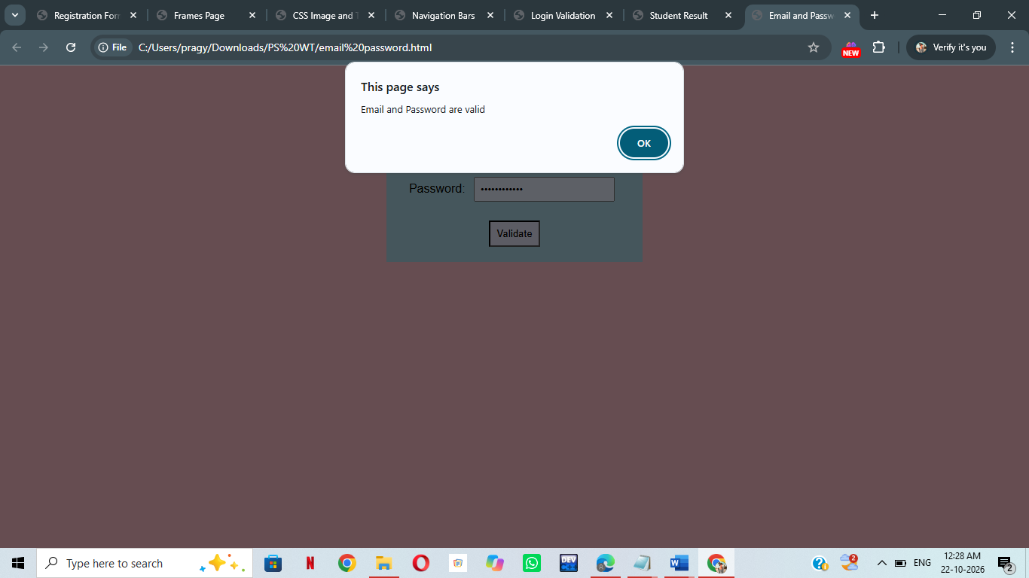

<html>
<head>
<title>Email and Password Validation</title>
<style>
body {
background-color: pink;
text-align: center;
font-family: Arial;
}
form {
background-color: lightblue;
width: 300px;
margin: auto;
padding: 20px;
}
input {
padding: 7px;
margin: 7px;
}
button {
padding: 8px;
background-color: lavender;
}
</style>
</head>
<body>
<h2>Email and Password Validation</h2>
<form onsubmit="return validate()">
Email:
<input type="text" id="email"><br><br>
Password:
<input type="password" id="password"><br><br>
<button type="submit">Validate</button>
</form>
<script>
function validate() {
var email = document.getElementById("email").value;
var password = document.getElementById("password").value;
var pattern = /^[^\s@]+@[^\s@]+\.[^\s@]+$/;

if (email == "" || password == "") {
alert("Please fill all fields");
}
else if (!pattern.test(email)) {
alert("Invalid Email Pattern");
}
else if (password.length < 8) {
alert("Password must be at least 8 characters");
}
else {
alert("Email and Password are valid");
}
return false;
}
</script>
</body>
</html>

